**Jenkin Deploy (Linux Server)**

**VPC:**

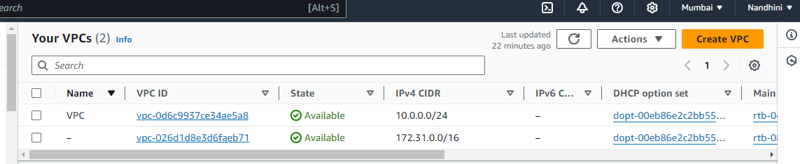

**SUBNETS:**

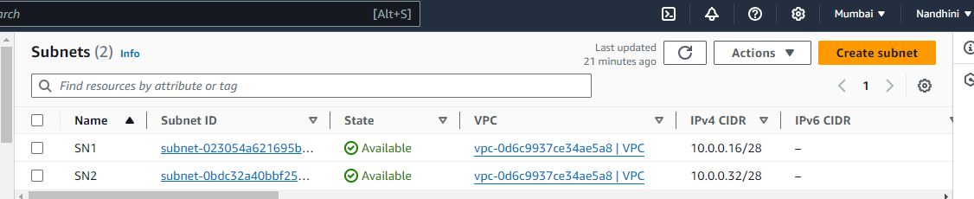

**ROUTE TABLE:**

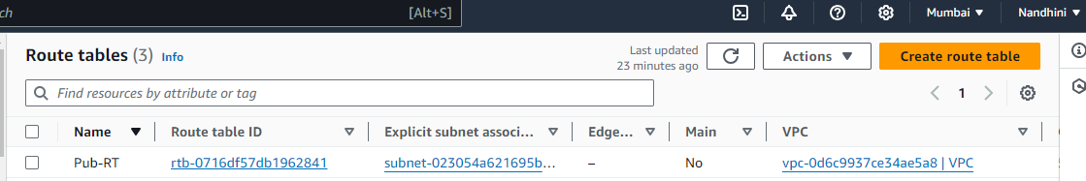

**IGW:**

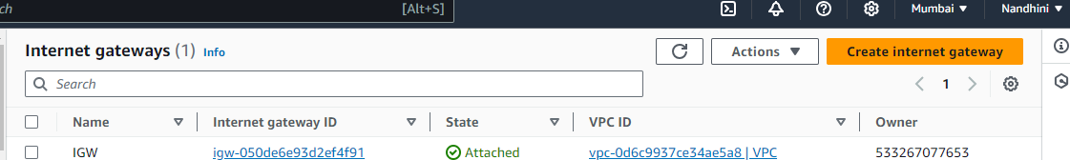

**Instance:**

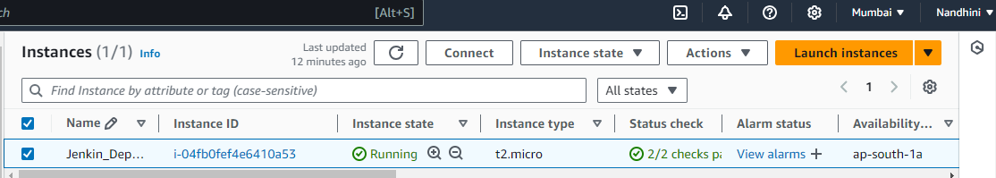

**JENKINS:**

